USER MANUAL

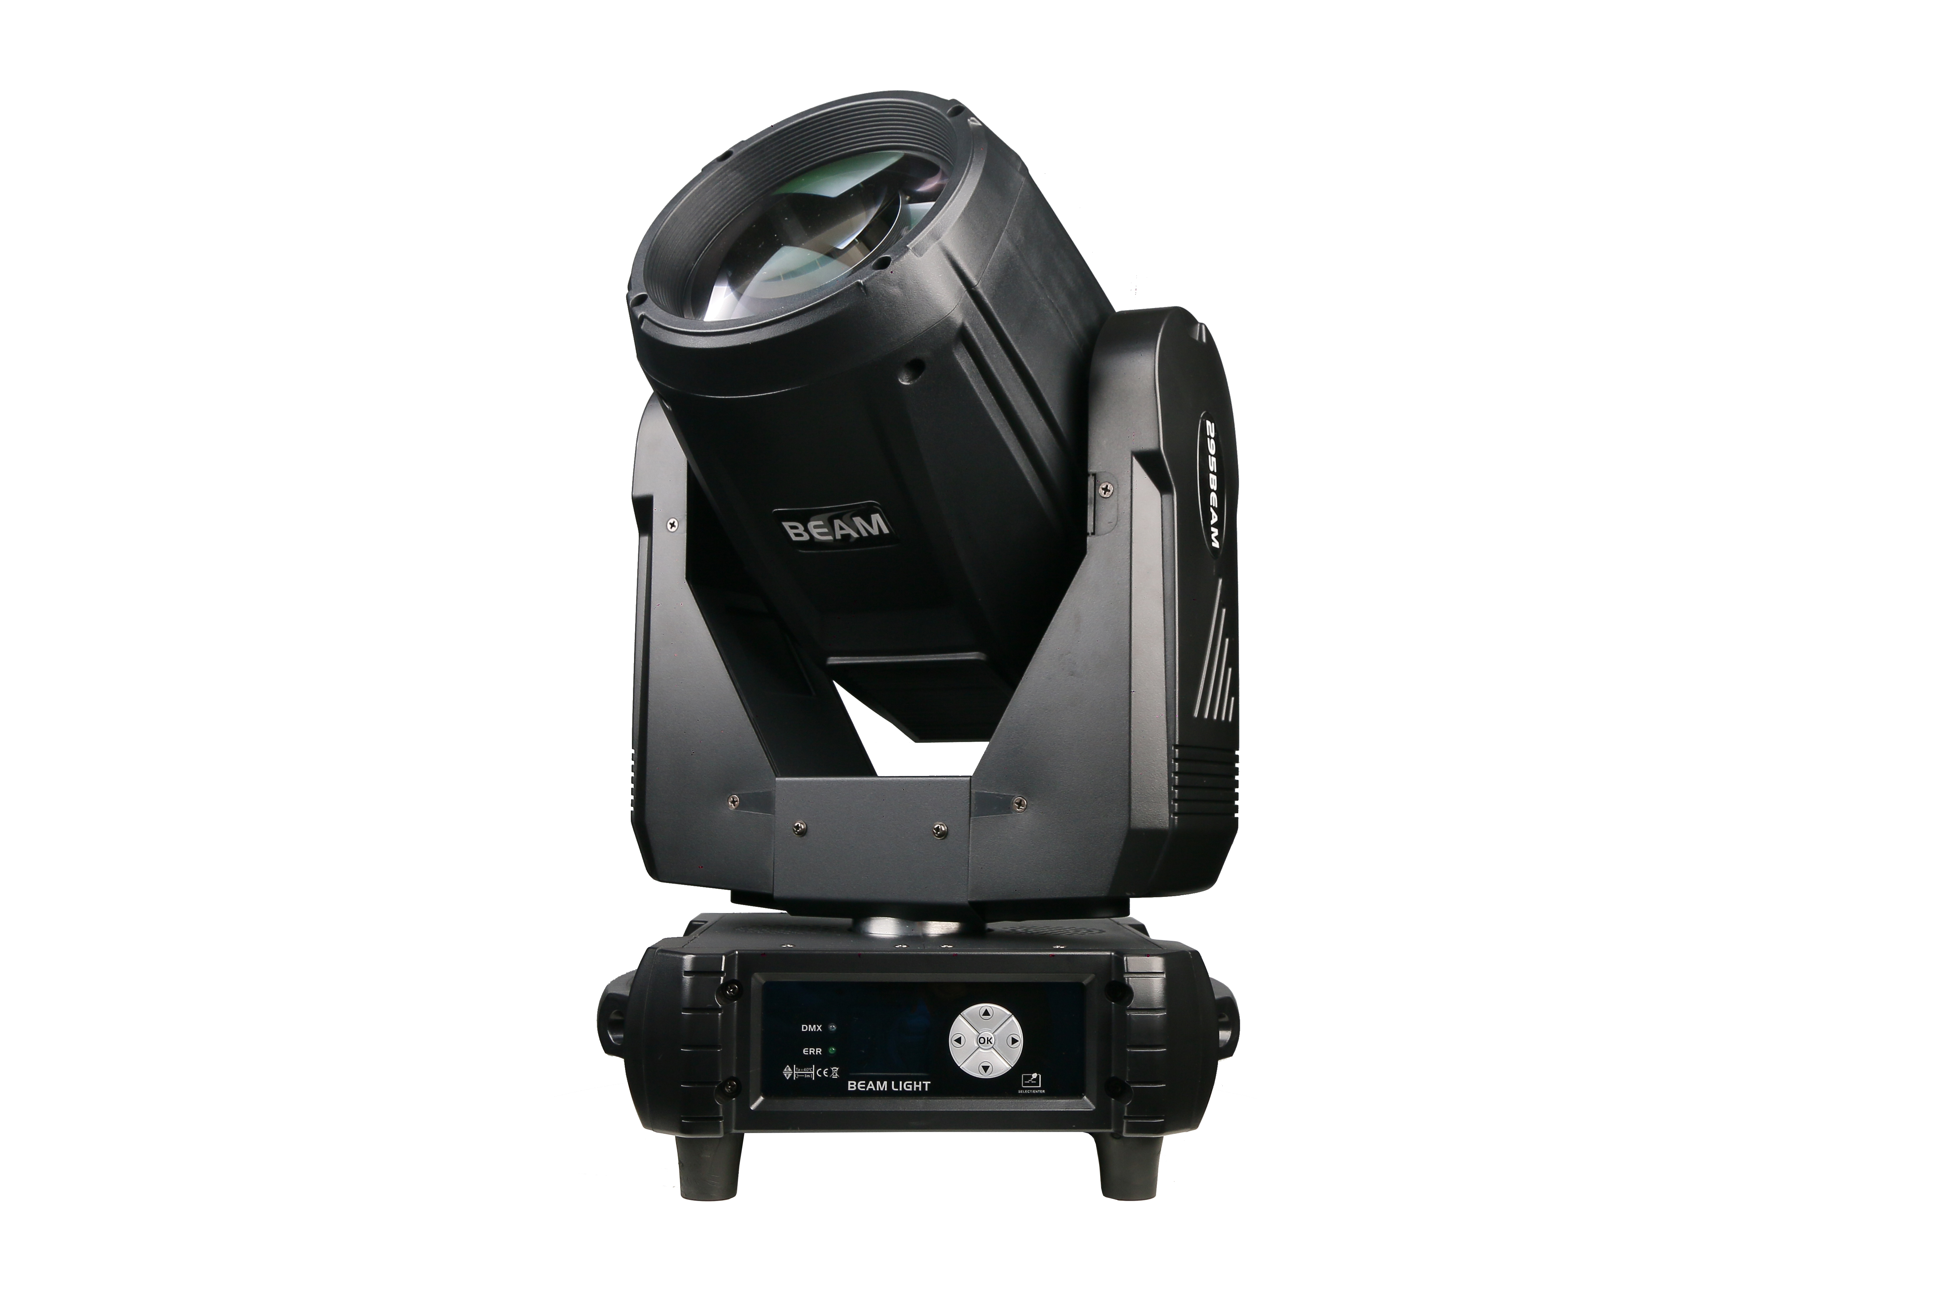

295W PRISM KING BEAM MOVING HEAD LIGHT

Please read and keep this manual carefully for further use!

Thank you for buying our professional Beam moving head.
This user manual includes important information for installation and operation, so please read this user manual carefully before installation and operation, and keep this user manual well for further use.
In order to install , operate, and maintain the lighting safety and correctly. We suggest that the installation and operation should be done by the verified technician and follow the instruction strictly.
Spare part includes:
Name | QTY | Unit
Fixture | 1 | PC
User manual | 1 | PC
Power cable | 1 | PC
bracket | 2 | PCS

Please check carefully that there is no damage caused by transportation. Should there be any, consult your local dealer.
Cautions
Before delivery, this device has passed strict inspection, Please follow the user manual strictly for operation, if this fixture is damaged by improper operation and mistake, the fixture will be out of warranty, and manufacture or dealer won’t be responsible for it. In case of any technology change in this manual,we won’t advise in further .



CAUTION!

Keep this device away from rain and moisture!

Unplug mains lead before opening the housing!

Warning!

Silkscreen symbol on light
Damages caused by the disregard of this user manual are not subject to warranty. The dealer will not accept liability for any resulting defects or problems.

Installation
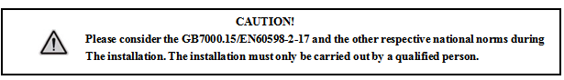

► This fixture is not suitable for direct installation on combustible material surface, please keep the fixture surface at least 0.5m from any combustible material.

► If you use the quick lock cam in hanging up the fixture, please make sure the quick lock fasteners turned in the quick lock holes correctly.
►The applicable temperature for the fixture is between -25°C to 45°C. Do not use the lighting under or above this temperature range.
►The truss for hanging the fixture should be able to hold 10 times weight of this fixture and no deformation after 1 hour hang.
►Please don’t stand under the fixture when install, uninstall, move or repair the fixture.
►Please ensure the light is connected correctly and invite professional technician to check and confirm the electrical data before installation.
►Please invite professional technician to check the fixture and installation each year.
Rigging：
Clamp
Bracket

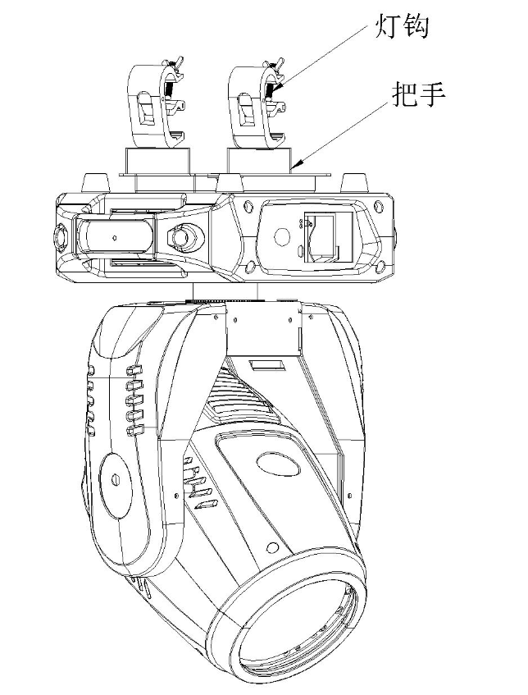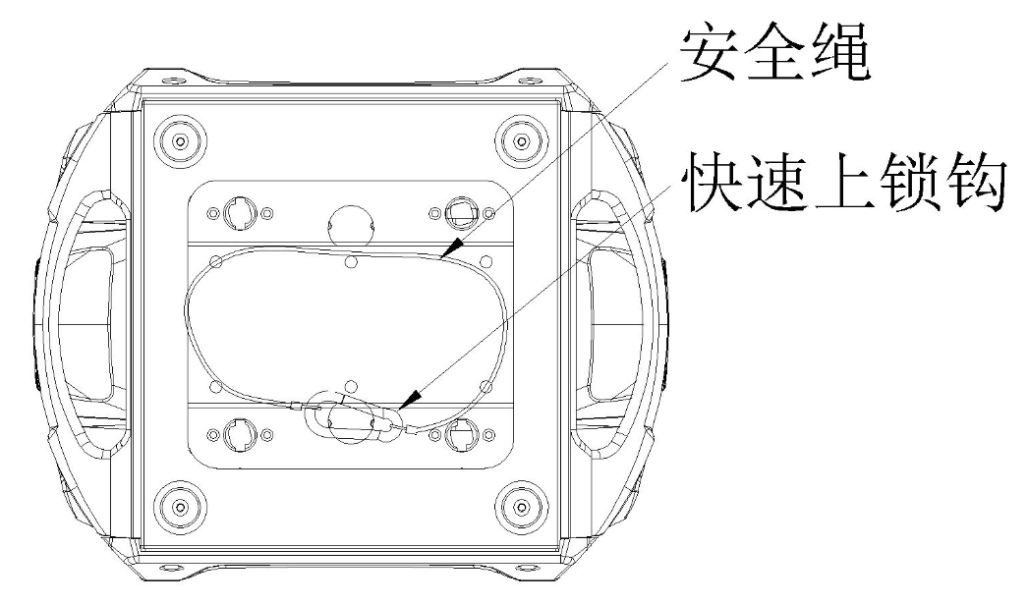
Safety rope

Quick lock

Insert the quick-lock fasteners of the first holder into the respective holes on the bottom of the device.Tighten the quick-lock fasteners fully clockwise.
Fix the clamp on truss or other fixture bracket.
Pull the safety rope through the holes on the bottom of the base and fasten it on the truss or other fixing point.
Note:This step is quite important to ensure that fixture will not drop down for the clamp damage.
Product specification

Power:
Power supply: 100-240V, 50/60HZ;
Power: 380W;

Lamp:
Bulb: 295W
Minimum beam angle: 2°
Dimming: 0-100% linear dimming
Strobe: 1-25Hz (built-in multiple strobe effects)

Motor scan parameters
Pan: 540° (16bit precision)
Tilt: 270° (16bit precision)

Effect features:
Color wheel:14 colors + open
Gobo wheel: 13 gobos + open
Prisms: 6-facet prism，8-facet prism，2-row 18-facet prism，3-row 48-facet prism，4-row 80-facet prism（can overlay）
Frost + 6-colors；

Control:
Channel mode: 18CH
Operation Mode: DMX/Master-slave/Auto/Sound/RDM
Display : touch LCD screen

Input & Output:
DMX connector: 3Pin XLR Input&Output
Power connector: Powercon socket

Other parameters:
IP rating: IP20
Product dimension: 310 * 270 * 490 mm
Carton size: 44*41*54cm
Net weight: 15KG

Display and operation

Panel description:
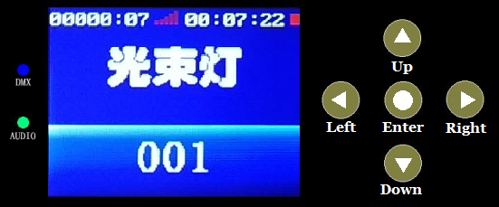

DMX | DMX signal indicator
AUDIO | Indicator light when AUDIO is triggered
Up | to select upward
Down | to select downward
Left | to select left / return
Right | to select right
ENTER | To Confirm
Time on the left side of the screen | The total time the system is in use (the display can be turned off in the standard settings)
Time on the right side of the screen | The total time of this power-on (can be turned off in the standard settings)
Vertical signal at the top of the screen | Current DMX signal connection signal strength  Red: No signal. White: Current signal strength
Square icon in the upper right corner of the screen | Green: normal, no errors
Square icon in the upper right corner of the screen | Red: There is an error (click the icon or "Information Menu/Error Message/View" to view the error

Display operation interface:
Standard | Default set | Enter? | Restore factory default parameters
Standard | Address | 001-512 | Set address code
Standard | DMX mode | Mode1  Mode2  Mode3  Mode4 | Select DMX control mode
Standard | Effect mode | No/Yes | effect disc automatically finds the shortest distance rotation operation
Standard | Started lamp | Off/on | Choose whether to turn on the bulb every time it is "on" or "off"
Standard | Switch lamp | Off/on | Turn on the light bulb manually
Standard | No signal | Clear  Hold | Keep DMX value or clear DMX channel value when there is no DMX signal
Standard | UI Color | Green  Blue  Golden  Gray | Choose screen menu color
Standard | Show time | No/Yes | Show running time timer on the main interface
Standard | Brightness | 000-255 | Adjust screen brightness
Standard | Screensaver | Off/On | Turn off the screen when there is no touch or key operation
Standard | XY encoder | No/Yes | Cancel or use XY automatic error correction function
Standard | X inversion | No/Yes | Select X axis forward or reverse operation
Standard | Y inversion | No/Yes | Select Y-axis forward or reverse operation
Standard | Focus inversion | No/Yes | Select the focus axis to run in the forward or reverse direction
Standard | Zoom inversion | No/Yes | Select the magnifying axis to run in the forward or reverse direction
Advanced | This setting is the main parameter setting of the lamp and requires permission
Info | Error List | No error/View | If there is no error or there is an error, click OK to view the error
Info | System ver | Vxxxxxxx | System version information
Info | Serial NO. | xxxxxxxx | Equipment factory number
Info | SYS timer | 00000.0H | Total running time of the system (hours)
Info | Run timer | 000:00 | Running time of this power-on (hours)）
Info | Lamp timer | 00000.0H | The total time the bulb on (hours)）
Info | Equip TEMP | 000 | The temperature of the main part of the equipment (need equipment support)
Info | Head TEMP | 000 | The temperature of the lamp head of the device (requires device support)
Info | FAN 1 Speed | 0000 RPM | fan 1 speed (requires equipment support)
Info | FAN 2 Speed | 0000 RPM | fan 2 speed (requires equipment support)
perform | Run mode | Auto/Sound | Auto/Sound operation
perform | Run speed | 255 | Auto operation speed
perform | Run cross | 255 | Set sliding steps for Auto/Sound operation (device support is required)
perform | Built-in 1 | Off/On | built-in test program 1
perform | Built-in 2 | Off/On | built-in test program 2
perform | User PRO 1 | Off/On | User self-programming program 1
perform | User PRO 2 | Off/On | User self-programming program 2
perform | User PRO 3 | Off/On | User self-programming program 3
perform | User PRO 4 | Off/On | User self-programming program 4
perform | Circle shape | Off/On | (Reserved)
perform | Shpae shape | Off/On | (Reserved)
perform | Shape range | 000 | (Reserved)
perform | Sound DB | 000 | Adjust Sound control sensitivity
Program | (Explain in detail on the next page)
Reset | System reset to initial position
Function Description
Manual control or programming function description:
1: This function can program up to 4 user programs, 4 programs can be run in series, that is to say, the 4 programs that have been programmed can be switched to on at the same time in the "Test Run" function, and program 1 is run first when running , Then to program 2, to program 3, then program 4, and then loop back to program 1, and so on and so on. Of course, you can also single-select operation.
2: Operations that can be achieved by programming function buttons:
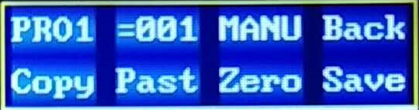
Select program, read program, select step, delete step, manual or console input, copy current step, paste to selected step, clear current step, save to selected program space

Manual control:
Manual/Console Press the up, down, left, and right buttons and the OK button to select the mode button to the manual position.
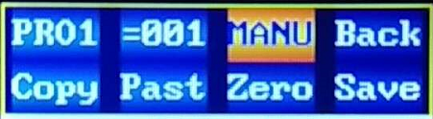
Then operate the up, down, left, and right buttons and the OK button to make the corresponding channel red, and press the up and down buttons to manually control.
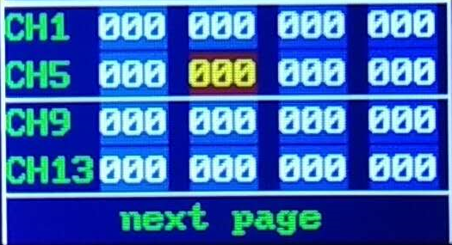

Manual control programming:
Select the PRO1-4 that needs to be saved, and after setting the channel value of one step through manual control, click the step (number button is the step) as shown in the figure, and press the up and down buttons to go to the next step. Then manually control and set the channel value, and the next step is and so on..

Delete step:
If there are too many programming steps, the following steps can be deleted. Select the step button and press the "Down" button to return to the previous step that is not needed. At this time, the number of the step is displayed as> 0XX. At this time, press and hold the OK button for 3 seconds, and the following steps can be deleted. The display becomes =0XX.
Copy step:
Press the copy button to copy all channel values ​​of the current step and temporarily store them in the memory pasteboard.
Paste step:
After copying, you can select any step, and paste the channel value of the pasteboard into the currently selected step channel.
Clear step:
Press the reset button to reset the channel value of the current step to zero.

Console control programming:
This device provides a more convenient console input programming function, and you can also use this function to enter the console program step by step to realize the function of copying the program programmed by the console.
As shown in the figure, select the manual/control console input mode as the console.
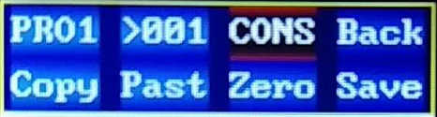
At this time, all channel values ​​are input by the DMX console, manual invalid, paste invalid, clear invalid, all channel values ​​display DMX values ​​in real time.
At this time, programming only needs console input, or the console runs the programmed steps in a single step, that is, enters the console program. This device only needs to click the next number and press the up arrow to realize programming.

Save the program:
After programming each step by manual input or console input, you can save this programming. Please make sure to select the save location PRO1--PRO4, please note that the saved step length is equal to the step value = 0XX, instead of seeing the step value> 0XX. Please delete the unnecessary steps later, refer to (Delete Steps", and then press Save.

Read the program and re-edit the program:
As shown in the figure, select the PRO1--PRO4 to be read out, then click the step button, and press the <Down> button to display "Read Out". Press the OK key at this time to read the selected program. The value displayed after reading is the maximum step value of the current program. If the program is empty, it will display as "Empty" or "No"
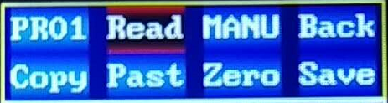
At this time, you can re-edit the program that has been read out. After editing, press Save to overwrite the current program, or select another PRO1--PRO4 space to save as.

Run the program:
If you need to run the programmed and saved program, please return to the "Test Run/Perform" function menu, click to select the corresponding user program, and switch to "On".
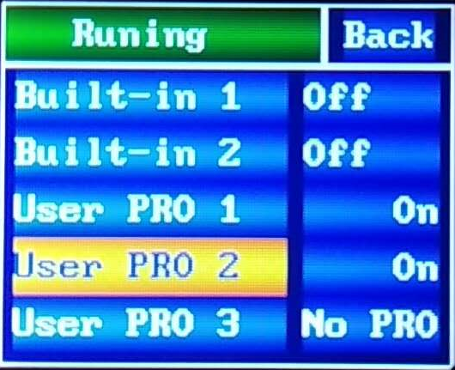

Gobo wheel
White 5
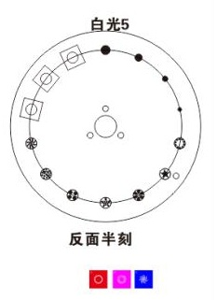
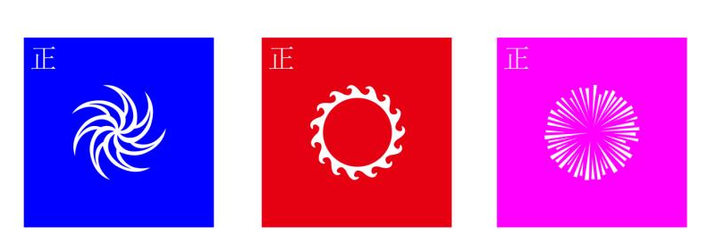
color sequence
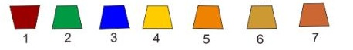
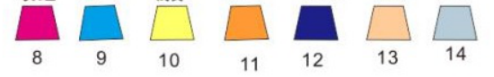

Six-color effect
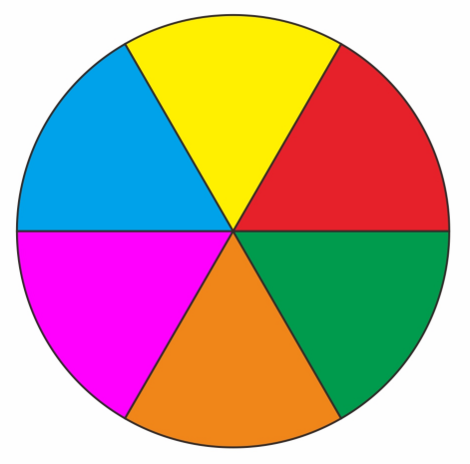
18 DMX channel
18CH | Function | Value | Details | Remarks
CH1 | color wheel | 255 | high speed rotation | gobo flowing
CH1 | color wheel | …… | …… | gobo flowing
CH1 | color wheel | 191 | low speed rotation | gobo flowing
CH1 | color wheel | 190 | low speed rotation | gobo flowing
CH1 | color wheel | …… | …… | gobo flowing
CH1 | color wheel | 150 | high speed rotation
CH1 | color wheel | 145-149 | color 14+ white
CH1 | color wheel | 140 | color 14
CH1 | color wheel | 135 | color 13 +color 14 | the value is 5N
CH1 | color wheel | 130 | color 13 | the value is 5N
CH1 | color wheel | 125 | color 12 +color 13 | the value is 5N
CH1 | color wheel | 120 | color 12 | the value is 5N
CH1 | color wheel | 115 | color 11 +color 12 | the value is 5N
CH1 | color wheel | 110 | color 11 | the value is 5N
CH1 | color wheel | 105 | color 10 +color 11 | the value is 5N
CH1 | color wheel | 100 | color 10 | the value is 5N
CH1 | color wheel | 95 | color 9 +color 10 | the value is 5N
CH1 | color wheel | 90 | color 9 | the value is 5N
CH1 | color wheel | 85 | color 8 +color 9 | the value is 5N
CH1 | color wheel | 80 | color 8 | the value is 5N
CH1 | color wheel | 75 | color 7 +color 8 | the value is 5N
CH1 | color wheel | 70 | color 7 | the value is 5N
CH1 | color wheel | 65 | color 6 +color 7 | the value is 5N
CH1 | color wheel | 60 | color 6 | the value is 5N
CH1 | color wheel | 55 | color 5 +color 6 | the value is 5N
CH1 | color wheel | 50 | color 5 | the value is 5N
CH1 | color wheel | 45 | color 4 +color 5 | the value is 5N
CH1 | color wheel | 40 | color 4 | the value is 5N
CH1 | color wheel | 35 | color 3 +color 4 | the value is 5N
CH1 | color wheel | 30 | color 3 | the value is 5N
CH1 | color wheel | 25 | color 2 +color 3 | the value is 5N
CH1 | color wheel | 20 | color 2 | the value is 5N
CH1 | color wheel | 15 | color 1 +color 2 | the value is 5N
CH1 | color wheel | 10 | color 1 | the value is 5N
CH1 | color wheel | 5 | white +color 1 | the value is 5N
CH1 | color wheel | 0 | white | the value is 5N
CH2 | strobe | 252-255 | shutter open | controlled by dimmer channel
CH2 | strobe | 239-251 | High speed random strobe
CH2 | strobe | 226-238 | middle speed random strobe
CH2 | strobe | 213-225 | low speed random strobe
CH2 | strobe | 208-212 | shutter open | controlled by dimmer channel
CH2 | strobe | 207 | Pulse strobe
CH2 | strobe | …… | ……
CH2 | strobe | 108 | Pulse strobe
CH2 | strobe | 104-107 | shutter open | controlled by dimmer channel
CH2 | strobe | 103 | strobe
CH2 | strobe | …… | ……
CH2 | strobe | 4 | strobe
CH2 | strobe | 0-3 | shutter off
CH3 | dimmer | 255 | dimmer 100%
CH3 | dimmer | …… | ……
CH3 | dimmer | 0 | dimmer 0%
CH4 | gobo wheel | 255 | gobo 13 shake at high speed | the value is 5N
CH4 | gobo wheel | …… | ……
CH4 | gobo wheel | 251 | gobo 13 shake at low speed
CH4 | gobo wheel | …… | ……（gobo 2 to gobo 12）
CH4 | gobo wheel | 195 | gobo 1 shake at high speed
CH4 | gobo wheel | …… | ……
CH4 | gobo wheel | 191 | gobo 1 shake at low speed
CH4 | gobo wheel | 190 | high speed rotation（clockwise）
CH4 | gobo wheel | …… | ……
CH4 | gobo wheel | 135 | low speed rotation（clockwise）
CH4 | gobo wheel | 130-134 | stop
CH4 | gobo wheel | 129 | low speed rotation（anticlockwise）
CH4 | gobo wheel | …… | ……
CH4 | gobo wheel | 70 | high speed rotation（anticlockwise）
CH4 | gobo wheel | 65-69 | gobo 13
CH4 | gobo wheel | 60 | gobo 12
CH4 | gobo wheel | 55 | gobo 11
CH4 | gobo wheel | 50 | gobo 10
CH4 | gobo wheel | 45 | gobo 9
CH4 | gobo wheel | 40 | gobo 8
CH4 | gobo wheel | 35 | gobo 7
CH4 | gobo wheel | 30 | gobo 6
CH4 | gobo wheel | 25 | gobo 5
CH4 | gobo wheel | 20 | gobo 4
CH4 | gobo wheel | 15 | gobo 3
CH4 | gobo wheel | 10 | gobo 2
CH4 | gobo wheel | 5 | gobo 1
CH4 | gobo wheel | 0 | white
CH5 | prism 1 | 200-255 | prism 2
CH5 | prism 1 | 100-199 | prism 1
CH5 | prism 1 | 0-99 | no effect
CH6 | prism 1 rotation | 255 | high speed rotation（clockwise）
CH6 | prism 1 rotation | …… | ……
CH6 | prism 1 rotation | 193 | low speed rotation（clockwise）
CH6 | prism 1 rotation | 191-192 | stop
CH6 | prism 1 rotation | 190 | low speed rotation（anticlockwise）
CH6 | prism 1 rotation | …… | ……
CH6 | prism 1 rotation | 127 | high speed rotation（anticlockwise）
CH6 | prism 1 rotation | 0-127 | adjust angle
CH7 | prism 12 | 200-255 | prism 5
CH7 | prism 12 | 101-199 | prism 4
CH7 | prism 12 | 10-100 | prism 3
CH7 | prism 12 | 0-9 | no effect
CH8 | prism 2 rotation | 255 | high speed rotation（clockwise）
CH8 | prism 2 rotation | …… | ……
CH8 | prism 2 rotation | 193 | low speed rotation（clockwise）
CH8 | prism 2 rotation | 191-192 | stop
CH8 | prism 2 rotation | 190 | low speed rotation（anticlockwise）
CH8 | prism 2 rotation | …… | ……
CH8 | prism 2 rotation | 127 | high speed rotation（anticlockwise）
CH8 | prism 2 rotation | 0-127 | adjust angle
CH9 | six color effect | 128-255 | six color effect
CH9 | six color effect | 0-127 | no six color effect
CH10 | focus | 255 | focus 100%
CH10 | focus | …… | ……
CH10 | focus | 0 | focus 0%
CH11 | focus fine | 0-255 | focus fine
CH12 | pan | 0-255 | 0-540 degree
CH13 | pan fine | 0-255 | 0-1 degree
CH14 | tilt | 0-255 | 0-270 degree
CH15 | tilt fine | 0-255 | 0-1 degree
CH16 | XY speed | 0-255 | from fast to slow
CH17 | frost | 128-255 | frost
CH17 | frost | 0-127 | no frost
CH18 | lamp control and reset | 250-255 | all motors reset | lamp ON/OFF after 5 seconds
CH18 | lamp control and reset | 211-244 | no function | lamp ON/OFF after 5 seconds
CH18 | lamp control and reset | 200-210 | lamp on | lamp ON/OFF after 5 seconds
CH18 | lamp control and reset | 111-199 | no function | lamp ON/OFF after 5 seconds
CH18 | lamp control and reset | 100-110 | lamp off | lamp ON/OFF after 5 seconds
CH18 | lamp control and reset | 0-99 | no function | lamp ON/OFF after 5 seconds

DMX-512 connection

Connect the provided XLR cable to the male 3-pin XLR output of your controller and the other side to the female 3-pin XLR input of the light.then connect the DMX signal to the first fixture to the 2nd fixture, after all fixtures are connected,

The signal cable should be two - core with screened cable with XLR input and output connectors. Please refer to the diagram below

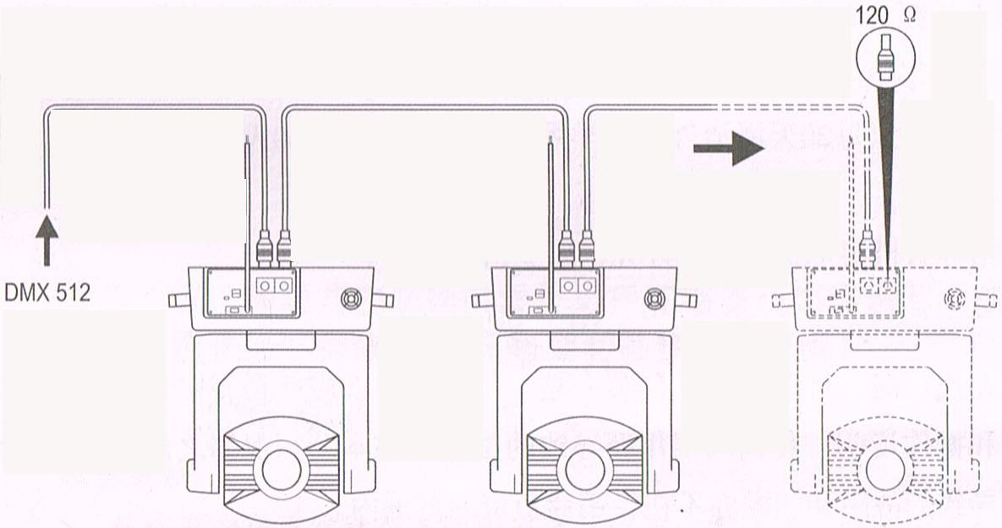

DMX terminator connection
If there are many lines or lights, it is recommended to use a DMX terminator to prevent DMX signal corruption, the DMX terminator is an simple XLR plug with a 120 Ω resistor connected between pins 2 and 3,which is then plugged into the output XLR socket of the last fixture in the chain.
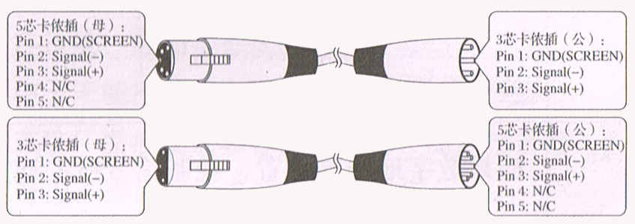
3-Pins connection
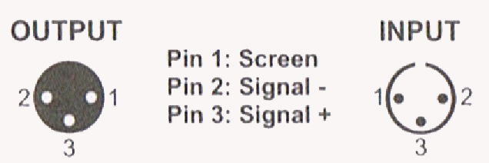
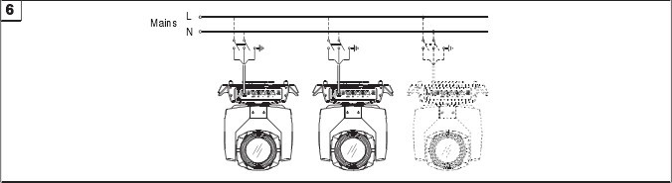
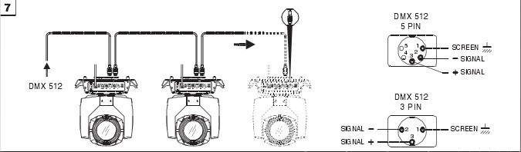

Cleaning and maintenance

Cleaning should be performed every 15-day period, by using a sponge which is dipped with alcohol, rather than wet cloth or other chemical liquid, to clean the mirror.

Cut off power before cleaning and maintenance!
CAUTION

Attention

Do not see directly light source when open the light, and make sure power off before do any installation or maintenance.

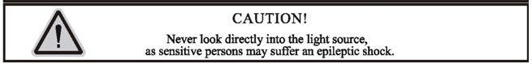

 Wires connection must be done professional person!
CAUTION

Cautions
Before delivery, this device has passed strict inspection, Please follow the user manual strictly for operation, if this fixture is damaged by improper operation and mistake, the fixture will be out of warranty, and manufacture or dealer won’t be responsible for it. In case of any technology change in this manual,we won’t advise in further .

Common issues instruction

Issues | Solve instruction
No power | Check power’s voltage
When power in, output light but the device cannot accept control signal | Check address setting and the control DMX cable connection well or not
The effect have light shadow | Check electronic focus DMX channel value, does suitable distance
Power down | The lamp maybe arrived end of using life, should change new lamp, and also check light source cleaning or not
Note: the maintenance should be done by the verified technician.

